Name : Mwangangi Neville Kalunda

Reg No: P15/142647/2021

Project proposal.

SMART HEALTH.

Introduction.

Health is a major sector in the republic of Kenya. The sector involves building and maintaining of hospitals, licensing of private owned clinics and pharmacies, management of health professionals etc. The ministry of health in Kenya is responsible for these services. The ministry has been able to set up multiple health facilities (14193 to be precise) around the country. Depending on the county, the 14193 stations are spread across according to the number of people in the county and the availability of professional health practitioners in that county.

Current situation

The following data shows the medical distribution in the country (This data is per listed in the Kenya Master Health Facility List. Sorted by county name) :

Baringo 292

Bomet 204

Bungoma 279

Busia 188

Elgeyo Marakwet 146

Embu 207

Garissa 206

Homa Bay 307

Isiolo 79

Kajiado 390

Kakamega 358

Kericho 277

Kiambu 744

Kilifi 395

Kirinyaga 231

Kisii 284

Kisumu 360

Kitui 443

Kwale 222

Laikipia 219

Lamu 68

Machakos 483

Makueni 353

Mandera 216

Marsabit 144

Meru 583

Migori 329

Mombasa 373

Muranga 382

Nairobi 1292

Nakuru 641

Nandi 253

Narok 222

Nyamira 202

Nyandarua 189

Nyeri 449

Samburu 142

Siaya 290

Taita Taveta 133

Tana River 87

Tharaka Nithi 201

Trans Nzoia 186

Turkana 283

Uasin Gishu 278

Vihiga 152

Wajir 164

West Pokot 177

These medical facilities may have been set up either by the government, through the community, or through professional health practitioners. These health facilities at the moment each act independently from the other. Only form of interconnection is through NHIF (National Health Insurance Fund) and other health insurances as forms of payment.

Structure

As per the Health Act 2017, a unified health system was established to coordinate the inter-relationship between the national government and county government systems in order to provide for regulation of health care services through a health care service provider, health products and health technologies. The health sector was put under monitoring of the county through a county executive department (with a County Director of Health) that was in line with the health policy guidelines for setting up a county health system that is answerable to the County Governor and the County Assembly. The county director of health was the technical advisor on matters of health in the county.

Levels of health facilities

The health facilities are divided into different levels The levels are:

1. Community facilities – Run by medical clinical officers.
2. Health Dispensaries – run by clinical officers.
3. Health centers – run by one doctor, clinical officers and nurses.
4. County hospitals – run by a director (who is a doctor).
5. County referral hospitals - run by Chief Executive Officers (who are medics by profession) and have big in-patient capacities.
6. National referral hospitals – same as level 5 (county referral) but offer specialized treatments to patients.

Problem statement.

With the emergence of the Kenya National Digital Master Plan for 2022 – 2032, an integrated health management system which integrates all health sub systems with a health portal is yet to be developed. The Kenya Master Health Facility List has done part of the task by keeping the available and licensed (by the government) names of the health facilities in its database and an ability to see the distribution. But there is one missing piece, the interconnectivity between the medical facilities and the ministry of health. The lack of this connection has brought about:

* Lack of a digitized form of data storage.
* Poor interconnection between medical institutes.
* Poor tracking of medical practitioners.
* Lack of a proper data recording of patient data and case.
* Poor handling of medicine in institutions.
* The ministry cannot access information from all major hospitals and clinics.

Methodology

This will be made possible with the construction of fibre optic cables from hotspots to medical facilities that will implement the transfer of data from the medical facilities to other medical facilities or to the government. These hotspots will be installed in business, rural and public centers (conveniently close to medical facilities). Data will be stored in form of a database kept in the ministry of health. The hotspots will have thin clients that will be able to access the database and routers to share information among hospitals. The host in hospitals will be making use of a user friendly application that allows them to access, send or update information to the database via the hotspots.

The following diagram shows a representation (Not accurate):

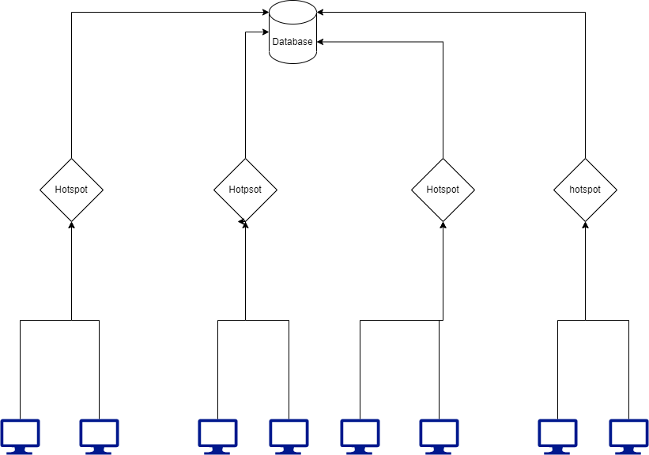

A Hotspot will connect with a group of hospitals and the hotspot will access the database directly to alter any change. Therefore a program is needed that will enable:

* Login of user (doctor, director).
* Update of any type of data.
* Communicate with other hospitals.
* And any other feature listed above.

With the interconnection the following is possible :

* Have a digital storage of patient, nurse and doctor data.
* Manage the staff organization in hospitals.
* Keep stock of medicine.
* Check for availability of spaces in hospitals.
* Store solutions of patient treatment.
* Register new born babies with unique identifications.
* Biometric checkups and vaccinations.
* Creating links between data centers and health centers to relay all data.
* Implementation staff cards that can be used to monitor personnel.